Declaring your Major

Usually, students have to declare a major by the end of their Sophomore year of college. By this point, you should have at least 1 semester’s worth of college courses complete, making you one step closer to declaring your major. And if you took some college courses during high school or the summer, you're even closer to having to declare your major! What if you still don't know what to major in? Here are a few tips on how to help you decide on a major:



1. Take some classes in a few fields you’re interested in. Most majors require you to take a few hours of electives anyway, so this will not be a detriment to graduating in 4 years. You’ll have a sneak peek of what the other classes in this major will be like and you can see if you actually like it or not. Sometimes we have misunderstandings due to how we view certain industries in pop culture, movies, TV shows, and music. Gray’s Anatomy is a great show, but most real medical professionals will tell you a normal workday is very different than what’s depicted on the show.



1. What are you good at? Most of the time, we enjoy doing things we are good at. Plus, we will benefit society and the world by sharing our talents. Not everyone is good at math, but if you’re a math wiz, the world is in need of your skills! Plus, you move up the ladder by being the best, so why not major in an industry where you naturally excel? Make a list of your strengths and weaknesses and compare them to the majors offered at your college to see where you’d best fit.



1. What kind of lifestyle do you want to live? If you want to be very rich, you will need to see what careers make the most money and major in something that will help you get one of those jobs. If you want to be a teacher, you’ll need to major in education. Where do you want to live? What kind of jobs do they have there? You’ll need to find a major that fits into the career or lifestyle you’d like to live.



1. Double major if you can’t decide between two. You can drop one later down the road if you decide you’re not interested in it anymore or if it's not for you. At least this way, you tried it and know for sure that it’s not for you.



1. Go to advising! Most colleges have advisers who specialize in helping students with these types of problems. For example, EKU has an office of Career and Co-Op that offers many services to help students declare their major, and find jobs and internships.



1. Still can’t decide? Major in General Studies and get take a variety of classes. This will help you be well-rounded and could potentially lead you to find a major or a grad program you’d be interested in pursuing once you find your niche. There are many jobs out there for a general studies major. Here are 15 jobs on Indeed for general studies majors: <https://www.indeed.com/career-advice/finding-a-job/general-studies-degree-jobs>

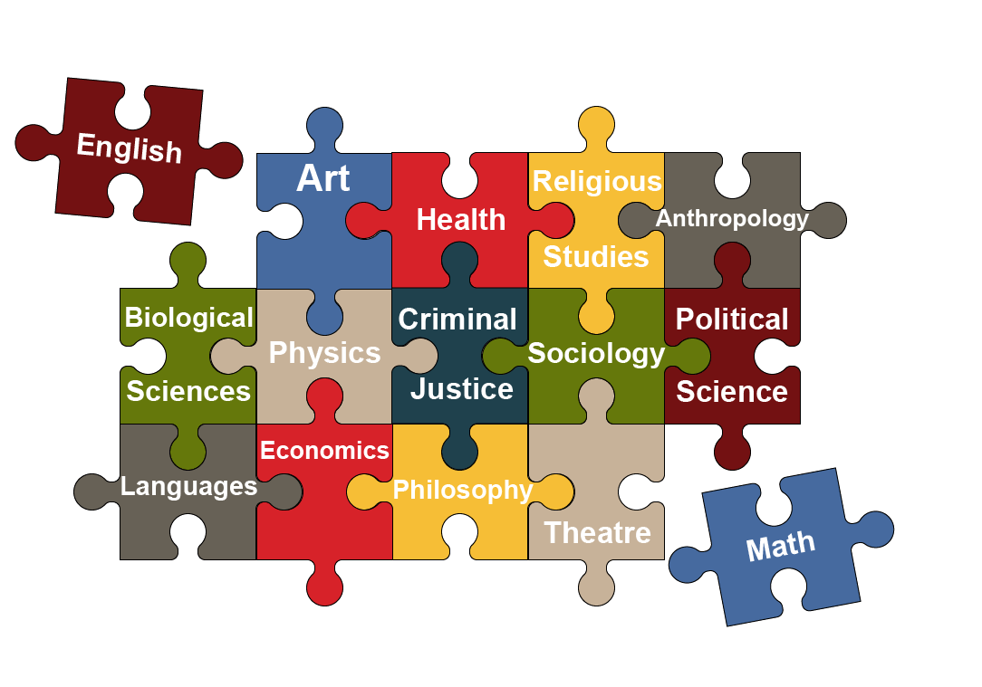

And remember, you CAN change your major. Just because you started off majoring in one thing, doesn’t mean you cannot change to a completely different major! You may have to stay in college for longer than 4 years depending on when you changed your major, and how many additional classes you’ll need for this new major, but it’s not the end of the world. It could be worth the change if you end up graduating with a degree that gets you a career you love!