**Alumni Blog - May 2023**

**Mental Health Awareness Month**

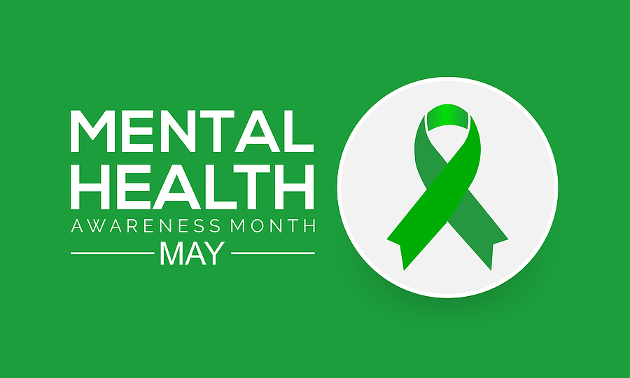

May is Mental Health Awareness Month, but in reality, every month should be! We have to take care of ourselves because it is so easy to let stress, anxiety, or depression really affect our well-being.

When we discuss mental health, it includes our emotional, psychological, and social well-being. It can also determine how we handle stressful events or circumstances in our lives. There are several factors that can contribute to mental health conditions such as biology, life experiences, and a family history of mental health problems. It is very important to talk about mental health because so many people are affected and there is a stigma often surrounding it. People tend to steer away from starting a conversation about mental health, but deciding to break down the barrier could help someone decide to seek out help if they are struggling.

Mental health plays a role in your life from the time you are a child through adulthood. College in particular can be a very stressful period in a person’s life, so it is especially important to take care of yourself. We will take a look at some symptoms that you could experience, ways to practice self-care, and different resources that can help you along your mental health journey.

**Mental health is as important as physical health!**

**Warning Signs and Symptoms**

If you think you might be struggling with handling stress or not feeling completely like yourself, these are some examples of behaviors that could indicate early warning signs of a problem.

* Sleep Patterns
* Are you sleeping too much? Are you not getting any sleep throughout the night?
* Loss of Enthusiasm in Activities
* Do you find yourself not wanting to participate in activities you used to love to do?
* Feeling Helpless or Hopeless
* Inability to Perform Daily Tasks
* Are you falling behind in school work or struggling to go to work?
* Feeling Unusually Worried, Angry, Upset, or Scared
* Low Self-Esteem
* Difficulty Concentrating

It is important to routinely check on yourself and develop coping skills for times that you experience these feelings. Maintaining positive and supportive relationships with friends and family members can make a huge difference in the way that you handle stressful times in your life.

**How Can You Practice Self-Care at Home?**

If you are starting to experience some warning signs, there are many different ways that you can practice self-care and self-compassion.

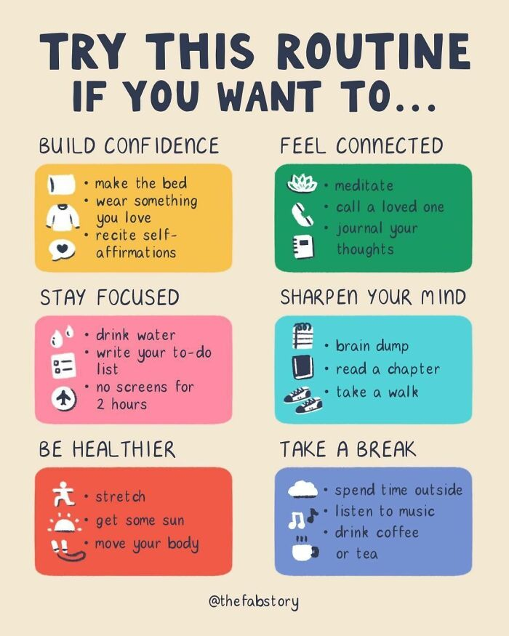

* Exercise
* Exercising releases endorphins and serotonin in your brain that can help with improving your mood.
* Keep a Journal
* Express your emotions, feelings, how you reacted in situations, and practice self-compassion by being kind to yourself. Learn to forgive yourself and not constantly beat yourself up over your emotions and reactions.
* Take Time for Yourself to Relax
* Watch a movie, take a bubble bath, or start a new book. Do an activity that will allow you to rest and take your mind off of stress.
* Go Outside
* Sunlight is a source of Vitamin D, which can also elevate your mood.
* Spend Time with Friends and Family
* Being around people that you love and love you can boost happiness and reduce stress.

Practicing these self-care activities can significantly help elevate your mood and start you off in the right direction for becoming more mentally healthy. In addition to these lifestyle changes, you can also receive help from different resources.

**Resources to Utilize in Your Mental Health Journey**

If you are stuck and have no idea where to start when seeking help with your mental health, there are a few places that you can start. Where can you go to get a better understanding of mental health?

* Primary Care Physician
* You can go talk to your doctor about the symptoms you are experiencing to get a better idea of treatment plans and options. They might recommend a treatment plan that includes medication and/or therapy sessions with a licensed therapist or psychiatrist.
* College Counseling Services
* Most colleges offer a counseling service that often is included in your tuition, so it is “free” to go talk with them about your mental health, stress, troubles in the classroom, etc. They are there to help the student body, and it is a wonderful resource to utilize.
* Research Reputable Websites for Information
* Some trustworthy websites that can provide information on mental health include: The National Institute of Mental Health, Mental Health America, and Substance Abuse and Mental Health Services.
* Crisis Hotlines
* If you or someone you know is in a state of crisis, there are different hotlines that you can utilize to talk to someone and/or get immediate help for your situation. (An infographic detailing some crisis hotlines is down below).

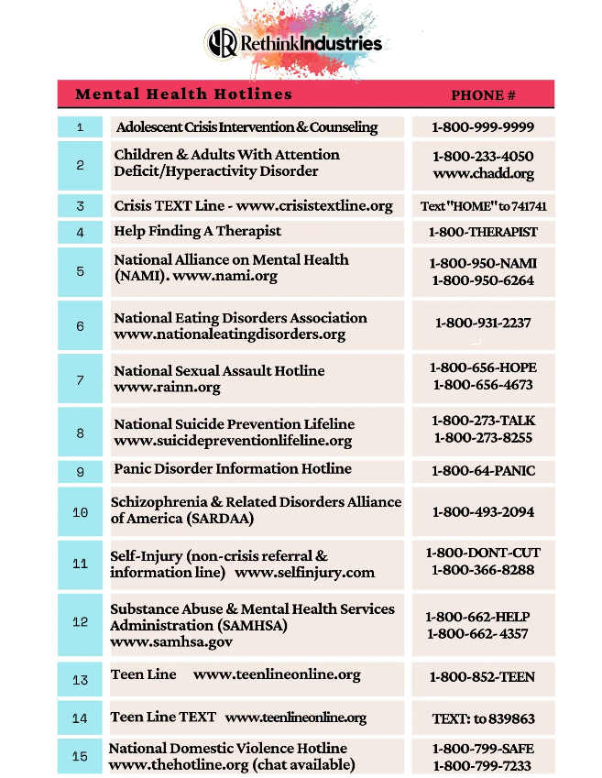

Wherever you are in your mental health journey, it is important to know that it isa *journey.* You work at your mental health and well-being your whole life. Mental Health is important to be physically healthy, cope with stress, have good relationships with others, and lead a happy life.

**If you or someone you know is struggling, do not hesitate to ask for help.**

